# Practical No: 08

**Aim:** Configure fast Ethernet on router using packet tracer

**Components:** Router, Switches, PC’s

**Theory:** Fast Ethernet is used for departmental backbones, connections to high-speed servers, and connections to workstations running bandwidth-intensive software such as CAD or multimedia applications.

**Cisco Packet tracer Setup:**

**Implementation:**

**Step 1:** Arrange all devices as shown below:

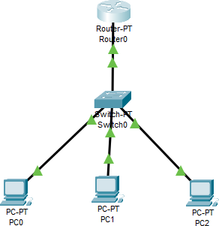

**Step 2:** Configure Router using CLI, using following commands: configure t

hostname R1

enable password cisco interface fa0/0

ip address 192.168.2.1 255.255.255.0

no shutdown exit

Exit

https://lh3.googleusercontent.com/uhPEf4RGWtnS5T7-t5iDVsj4y2mVdxPlx2y34CqzYSSETwLOWs3YHQv7xGQxtztj9fLsLPsfiUpb7hnSu7HNH6SpQdkC_qvkg5pNPfL8zX8p5JIjS4s4JijeZ748l6EnTN_aL1xMwEWQzGEZeSoXTdepBJ9W20SWekI1ILJD3e7wAcNeZKCXgGjayA

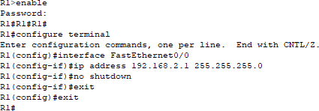

**Step 3:** Configure All PC’s and check the connection.

|  |  |  |  |
| --- | --- | --- | --- |
| **Device** | **Interface** | **IPv4 address** | **Other** |
| PC0 | IP config | 192.168.2.2 | Default Gateway:  192.168.2.1 |
| PC1 | IP config | 192.168.2.3 | Default Gateway:  192.168.2.1 |
| PC2 | IP config | 192.168.2.4 | Default Gateway: 192.168.2.1 |

**Step 4:** Ping 192.168.2.1 with all the PCs.

**Output:**

